In this report, I will demonstrate how the program is being run and what are the expected outcomes for each demonstration.

Firstly, I will install the pycryptodome library as well as prepare a few text files that will be used to encrypt using substitution cipher on the contents such as sample_test_1.txt, sample_test_2.txt, sample_test_3.txt as shown below.

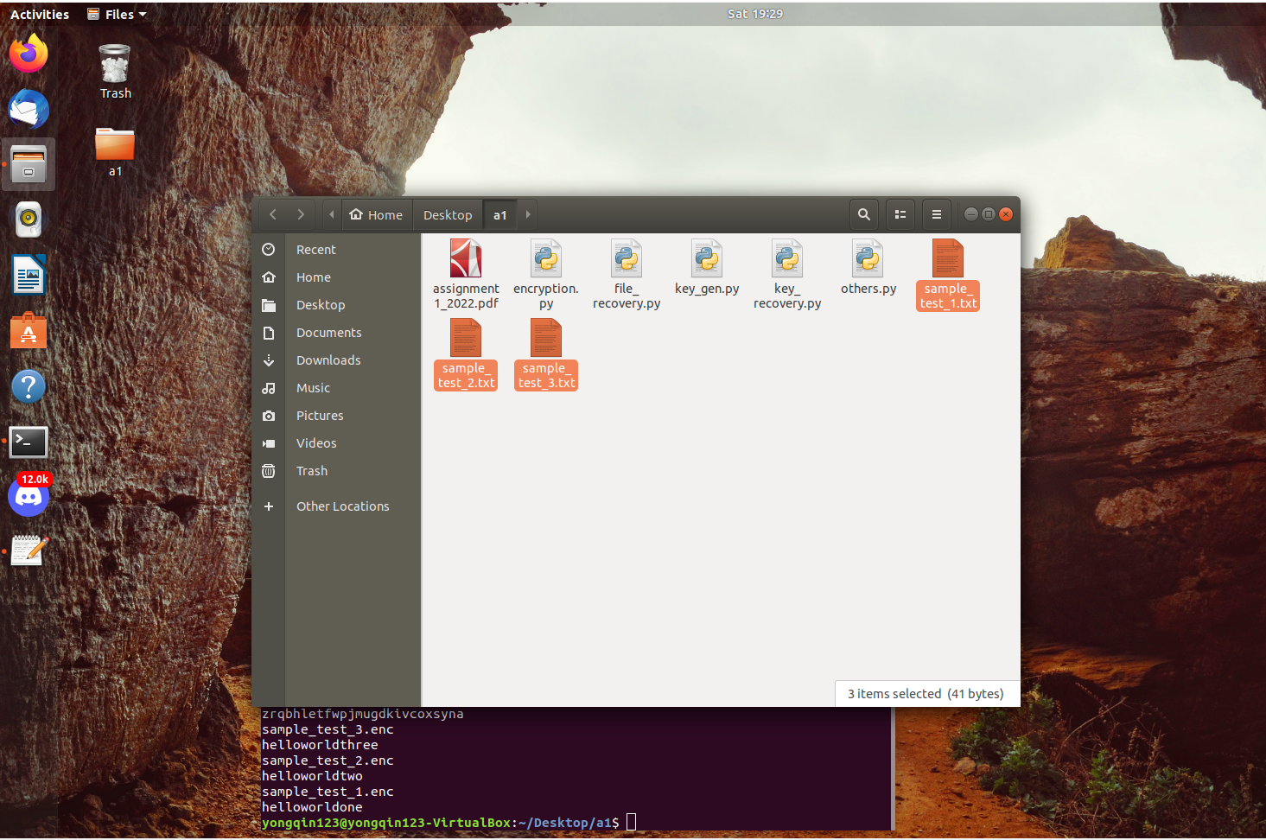

Their contents are as such:

Secondly, I will run the encryption python program (encryption.py) which will generate three .enc files as well as adding commenting to the other python files in the same directory. There will be 3 files generated such as ransompkey.pem, receiver.pem, key.bin.

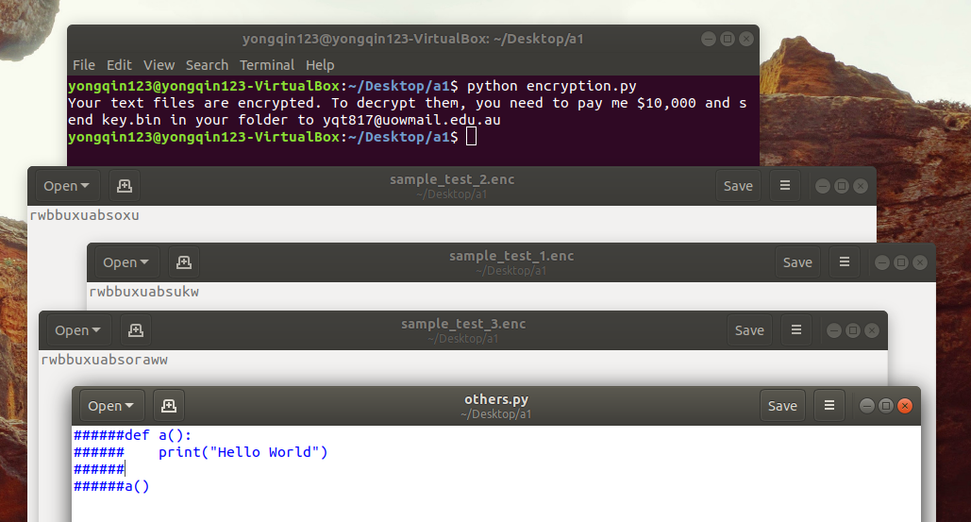

Thirdly, using key.bin and privatekey.pem, I will be able to decrypt the encrypted key stored in the key.bin as shown below, using the key_recovery.py file.

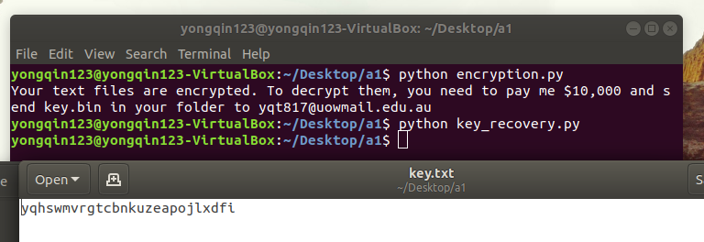

Lastly, I will be able to decrypt the substituted cipher text inside the .enc files by running the file_recovery.py file using the key stored in key.txt.

